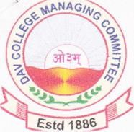**D.A.V. PUBLIC SCHOOL SIWAN**

(Sr.Sec.)AffiliatedtoCBSE,NewDelhi

(under

DAV College Managing Committee,NewDelhi

Dedicated to Excellence

E-mail: davsiwan.@gmail.com

Sr.Wing:9416387

Website: www.davsiwan.org

YEAR PLANNER 2023—24

Co-Curricular Activities (Senior Wing)

# APRIL 2023

3th Mahavir Jayanti Information

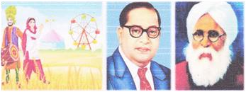13th Baisakhi ,B.R.Ambedkar Jayanti

Information (IV'-XII)

19th Mahatma Hansraj Birthday information

& Investiture Ceremony (IV-XII)

22th Parshuram Jayanti, earth day

# MAY 2023

13th Mother's Day Celebration (IV-VII)

20th Create First Aid Box(IV-V)

Picture Perception (VI-VIII)

Talent Search for New Comers

JUNE 2023 SUMMER VACATION

# JULY 2023

15th Chain Spelling (IV-V)



Sentence Race (VI-VII)

Blindfold Conversation (VIII-X)

 Declamation (Hindi/English) XI-XII

26th Shalok Uchcharan (VI-VIII)

Painting Activity (IV-V)Theme:- Patriotic

Calligraphy (Hindi/English )IX-X

31st Udham Singh Shahidi Diwas (Information)IV-XII

# August 2023

15th Independence Day Celebration (IV-XII)

19th Teej Celebration

28th Rangoli (Theme Rakhi) IV-VII

Art&Craft(Theme Rakhi) VIII

25th to 31st: Science Week(IV-X)

# September-2023

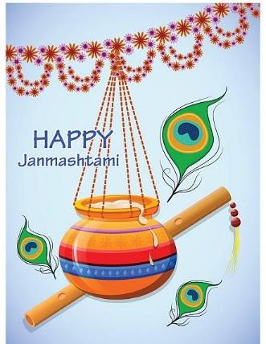

5th Teacher's Day(Information) IV-XII

6th Janamashtami Celebration (IV-VIII)

14th HindiDivas (Information)IV-XII

23th Master Chef(IV-V)

# October-2023

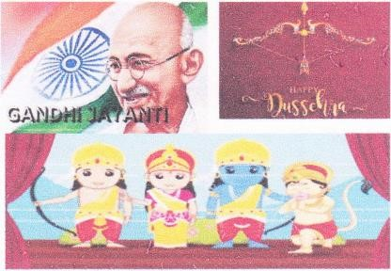1st Mahatma Gandhi Jayanti (Information) (IV-XII)

21st Dussehra Celebration (IV-VIII)

Ram Leela Play(Boys)

Dandia Dance (Girls)

28th Maharishi Valmiki Jayanti Information

31st Haryana Day Celebration (IV-XII)

# November-2023

11th Glitter Tape Diwali Card(JV-V)

Lantern Making (VI-VII)

Noise Free Fire Cracker Craft(VIII)

 Chaupaiyan Competition (IX-X)

Diwali celebration (IV-XII)

14th Children’s Day Celebration

Matinee Show (Girls)

Basket Ball Match (XI-XII)Boys

Tug ofWar (XI-XII)Girls

16th Yoga & Meditation

23th Basket Ball Match

December-2023

1st – 2nd Fit India Movement

1st Dumble and Lazium (IV- VII)

16th  Yoga and Meditation (VIII – X)

22nd Mathematics Day

23rd Christmas Day Celebration (IV- XII)

25th BasketBall Match (XI-XII) Boys

Tug of War (XI – XII) Girls

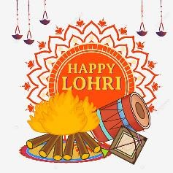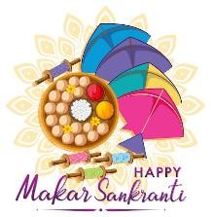

# January-2024

13th Lohri & Makar Sakranti Celebration (IV-XII)

25th Republic Day & Basant Panchmi Celebration(IV -XII)

Saraswati Jayanti Information (IV-XII)

# February,2024

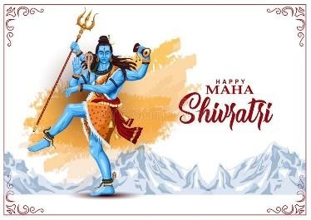

18th Maha Shivratri Information (IV-XII)

**PTM Schedule**

April  *8th*

May  *13th*

July  *8th*

August *12th*

September *8th*

October *14th*

November *11th*

December  *9th*

January *13th*

February *10th*

**Holidays & Vacations 2023-24**

SNo HOLIDAY DATE DAY

DAY

1. MAKAR SAKRANTI 14-01-2023 SATURDAY
2. REPUBLIC DAY& 26-01-2023 THURSDAY

BASANT PANCHAMI

1. MAHA SHIVARATRI 18-02-2023 SATURDAY
2. HOLI 08-03-2023 WEDNESDAY

1. RAM NAVAMI 30-03-2023 THURSDAY
2. MAHAVIR JAYANTI 04-04-2023 TUESDAY
3. GOOD FRIDAY 07-04-2023 FRIDAY
4. AMBEDKAR JAYANTI 14-04-2023 FRIDAY
5. ID-UL- FITR 22-04-2023 SATURDAY
6. BUDH PURNIMA 05-05-2023 FRIDAY
7. I D-UL- ZUHA (BAKRID 29-06-2023 THURSDAY
8. MUHARRAM 29-07-2023 SATURDAY
9. INDEPENDENCE DAY 15-08-2023 TUESDAY
10. RAKSHA BANDHAN 30-08-2023 WEDNESDAY
11. JANMASHTAMI 07-09-2023 THURSDAY
12. MILAD-UN-NABI 28-09-2023 THURSDAY

OR ID-E-MILAD

1. GANDHI JAYANTI 02-10-2023 MONDAY
2. DUSSEHRA HOLIDAYS 21-10-2023 to 24-10-23 SATURDAY TO TUESDAY
3. MAHARISHI VALMIKI'S BIRTHDAY 28-10-2023 SATURDAY
4. (KARWA CHOUTH) & HARYANA DAY 01-11-2023 WEDNESDAY
5. DIWALI (DEEPAVALI) BREAK 11-11-2023 to 15 -11-2023 SATURDAY TO WEDNESDAY
6. GURU NANAK’S BIRTHDAY 27-11-2023 MONDAY
7. CHRISTMAS & SWAMI 25-12-2023 MONDAY

SHRADDHANAND BALIDAN DIWAS

1. MAKAR SAKRANTI 14-01-2024 SUNDAY
2. REPUBLIC DA Y 26-01-2024 FRIDAY
3. BASANT PANCHAMI 14-02-2024 WEDNESDAY
4. HOLI 25-03-2024 MONDAY
5. RAM NAVAMI 29-03-2024 FRIDAY

As per the direction of Haryana Government.